The content of “all_script.py” is here:
https://colab.research.google.com/drive/1yL6JzHqlq4U0yifdyZZHaJdyOYKLnhjr?usp=sharing

!cd /mnt/c/Users/111/PY_HW
!wget https://raw.githubusercontent.com/school-brainhack/school-brainhack.github.io/main/content/en/modules/python_scripts/message_encrypted.txt
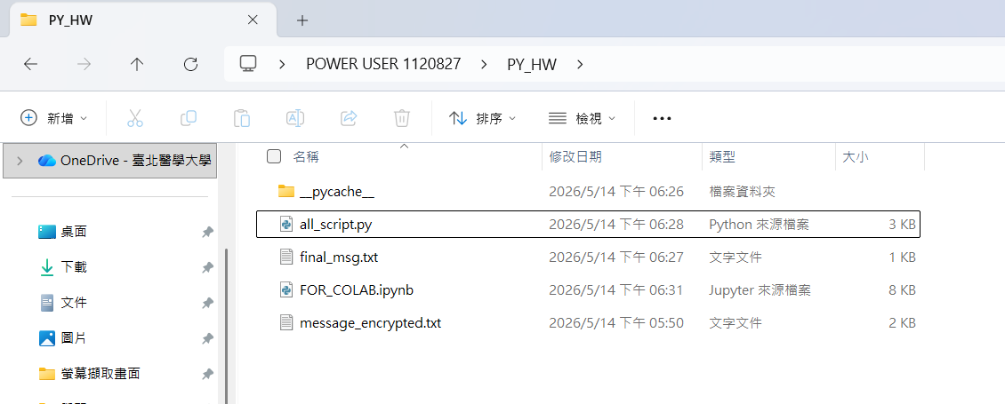

all_script.py is as below(it’s useful_functions + cypher_script)
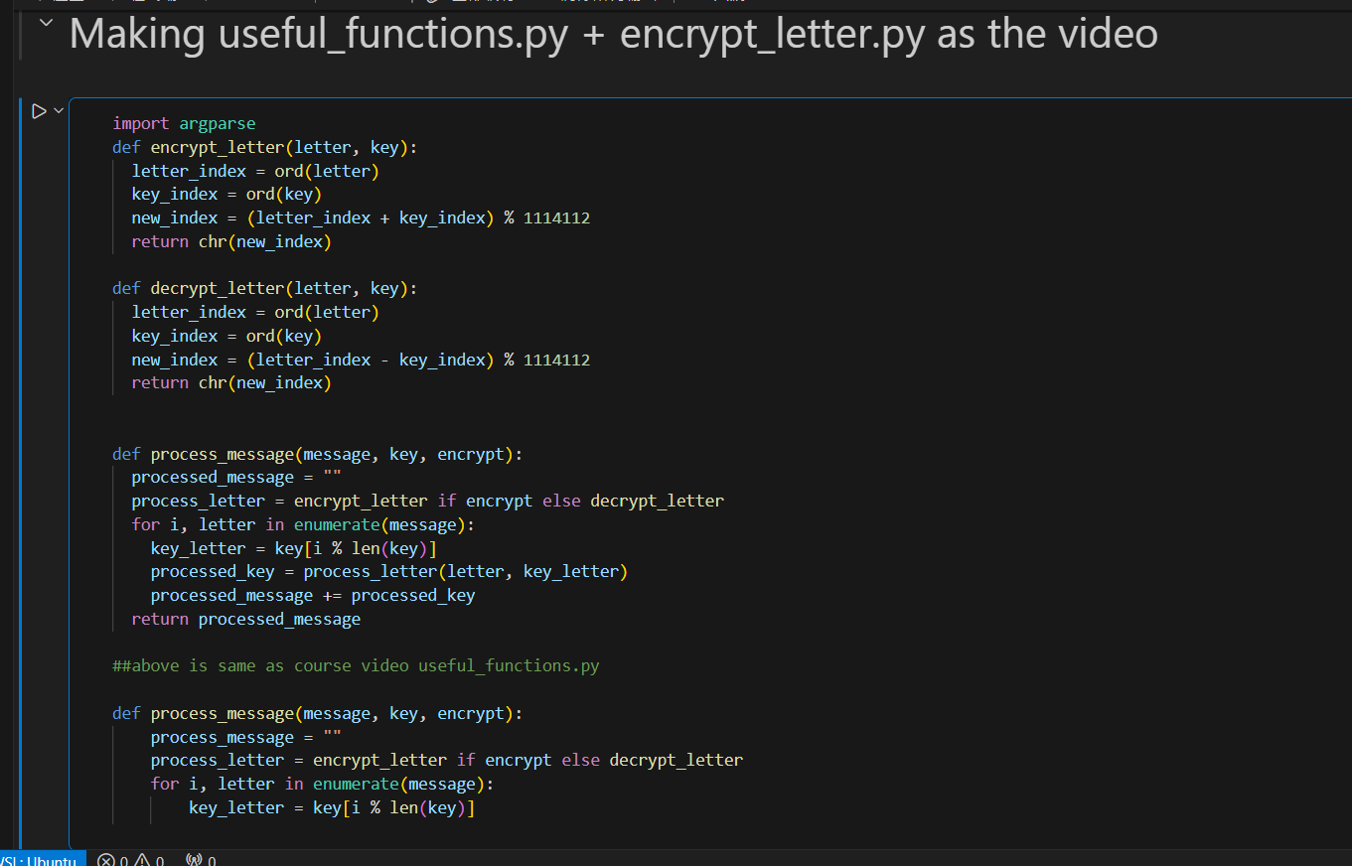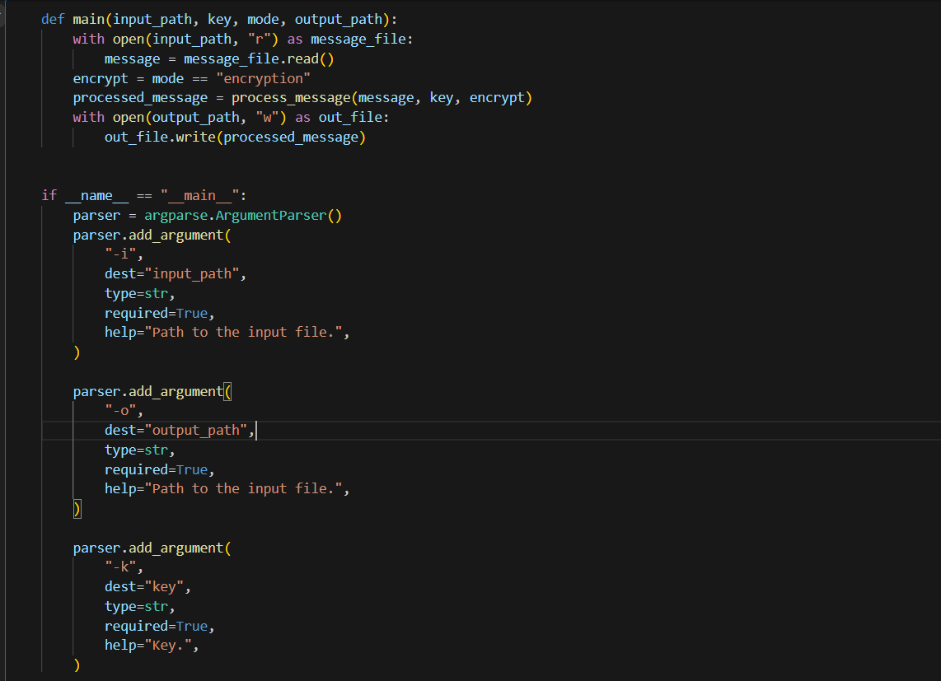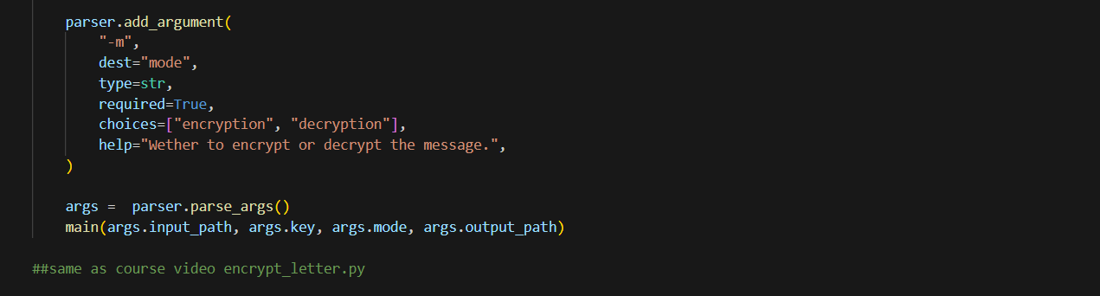

After python all_script.py -i /mnt/c/Users/111/PY_HW/message_encrypted.txt -o /mnt/c/Users/111/PY_HW/final_msg.txt -k my_super_secret_key -m decryption

final_msg.txt pop out
